CLINICAL CALCULATIONS
DIMENSIONAL ANALYSIS

Dimensional analysis is for the process of manipulating units. This allows you to eliminate or cancel unwanted units. Dimensional analysis eliminates the need to memorize formulas.
Conversions and Abbreviations to remember
1,000 mcg = 1 mg gtt = drop mcg = microgram
1,000 mg = 1 g IM = intramuscular mg = milligram
1,000 g = 1 kg IV = intravenous g = gram
1, 000 ml = 1 L IVP = intravenous push ml = milliliter
2.2 lbs = 1 kg BID = twice a day L = liter
1 oz = 30 ml TID = three times a day oz = ounce
gr1= 60 mg IVPB = intravenous piggyback gr = grain
1 cc = 1 ml PO = oral (by mouth) tsp= teaspoon
1tsp = 5 ml Tbsp= tablespoon
1 Tbsp = 15 ml
1. CONVERSION FACTORS USING DIMENSIONAL ANALYSIS:
Example: 1kg = 1000g
1kg or 1000g
1000g 1kg.
- Identify the desired unit.
- Identify the equivalent needed.
- Write the equivalent in fraction format, keeping the desired unit in the numerator (top) of the fraction. This is written first in the equation.
- Label all factors in the equation, and place the unit that you desire at the end of the equation.
- Identify the unwanted or undesired units, and cancel them. Reduce to the lowest terms if possible.
- If all labels except the answer label are not eliminated, recheck the equation.
- Perform the mathematical process indicated.
Examples:
1.5g = _____ mg 1.5g X 1000mg = 1500mg
1g
110lb = ____ kg 110lb X 1kg = 50 kg
2.2lb
2. MEDICATION CALCULATION
Six Step Solution:
- Write the label for the answer on the right side of the equation. (oral solid forms, tabs or caps: oral liquid form, milliliters (mL))
- On the left side of the equation, enter the desired dosage as a fraction.
- Enter the conversion factors as fractions to work toward the desired label (Equals over equals).
- Cancel all labels that are in both the numerator and the denominator.
- Do the math: multiply the numerators; multiply the denominators: then divide the numerator by the denominator.
- Ask yourself if the answer makes logical sense.

Example 1: Order: Lasix (furosemide) 40 mg p.o. daily
Available: tablets labeled 20 mg
The unit of measure desired in the problem is tablets.
Tablets/20mg
40mg X tablets = 40 tablets = 2 tablets of Lasix (furosemide)
20mg 20
Example 2: Order Gentamicin 55mg IM q8hr
Available: Gentamicin 80mg per 2ml
The unit of measure desired in the problem is milliliters.
2ml/80mg gentamicin
55mg gentamicin X 2 ml gentamicin = 110mL gentamicin = 1.375 ml
80mg gentamicin 80

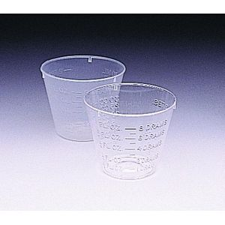
Medication dispensing cups
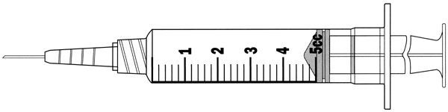
5 ml syringe

3. COMPONENTS OF A DRUG LABEL:

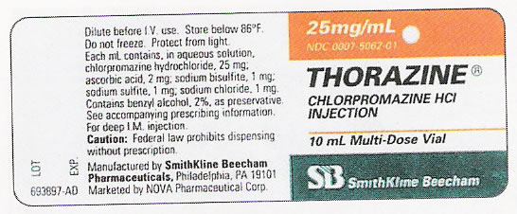

1. Name of the drug, including the trade name (name given by pharmaceutical company, identified with a trademark symbol) and the generic name (chemical name given to the drug)
2. Dosage of medication
3. Form of medication
4. Expiration date
5. Lot number or batch number (the manufacturer’s batch series for this medication
6. Manufacturer

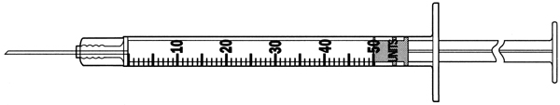
Insulin Syringe
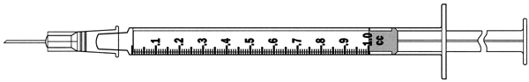
Tuberculin syringe

